Installing kubeadm | Kubernetes

Steps to Install Kubernetes on Ubuntu 20
Create 3 Ubuntu Pro 20.04 LTS linux servers with m5.large( min 3 to 8 gb)

Ubuntu Pro 20.04 LTS

ami-00ca19b9fb851ec1b

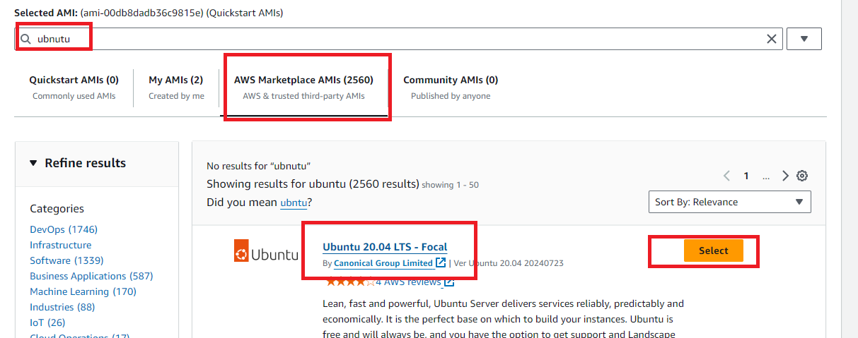

Set up Docker
ON 3 servers( on master and nodes)
- Create 3 aws ec2 instance with ubuntu 20 and m5.large
- sudo apt-get update
- sudo apt-get install docker.io -y
- sudo systemctl enable docker
- sudo systemctl restart docker

Install Kubernetes
ON 3 servers( on master and nodes)
- sudo apt-get update
- sudo apt-get install -y apt-transport-https ca-certificates curl gpg

- sudo mkdir -p -m 755 /etc/apt/keyrings

- curl -fsSL https://pkgs.k8s.io/core:/stable:/v1.30/deb/Release.key | sudo gpg --dearmor -o /etc/apt/keyrings/kubernetes-apt-keyring.gpg

- echo 'deb [signed-by=/etc/apt/keyrings/kubernetes-apt-keyring.gpg] https://pkgs.k8s.io/core:/stable:/v1.30/deb/ /' | sudo tee /etc/apt/sources.list.d/kubernetes.list

- sudo apt-get update

- sudo apt-get install -y kubelet kubeadm kubectl

- sudo apt-mark hold kubelet kubeadm kubectl

- sudo systemctl enable --now kubelet

ON Master only:
15) sudo kubeadm init --pod-network-cidr=10.244.0.0/16
- mkdir -p $HOME/.kube
- sudo cp -i /etc/kubernetes/admin.conf $HOME/.kube/config
- sudo chown $(id -u):$(id -g) $HOME/.kube/config
- sudo kubectl apply -f https://raw.githubusercontent.com/coreos/flannel/master/Documentation/kube-flannel.yml

ON All NODES:

- kubeadm join --discovery-token abcdef.1234567890abcdef --discovery-token-ca-cert-hash sha256:1234..cdef 1.2.3.4:6443
ON Master:
- kubectl get nodes
- kubectl get pods

Git use?

- Create github account and login
- Create a token(password)
- Install git on your laptop
- Create a remote remote repo
- Open terminal on VC and execute below commands
(only ones)
echo "# myK8s_DS_6AM_27oct25" >> README.md
git init
git add README.md
git commit -m "first commit"
git config --global user.name "YourUsername"
git config --global user.email "YourEmail"
git commit -m "first commit"
git branch -M main
git remote add origin https://github.com/maha4dsvc/myK8s_DS_6AM_27oct25.git
git push -u origin main
(username/password/token)

On monster (only ones)
# git clone https://github.com/maha4dsvc/myK8s_DS_6AM_27oct25.git
# cd myK8s_DS_6AM_27may25
# ls

- For every change,

On VSC
git add -A
git commit -m “comment”
git push

On master
# git pull

https://github.com/maha4dsvc/myK8s_DS_6AM_27oct25

